Output

1. product_id product_name \

0 B07JW9H4J1 Wayona Nylon Braided USB to Lightning Fast Cha...

1 B098NS6PVG Ambrane Unbreakable 60W / 3A Fast Charging 1.5...

2 B096MSW6CT Sounce Fast Phone Charging Cable & Data Sync U...

3 B08HDJ86NZ boAt Deuce USB 300 2 in 1 Type-C & Micro USB S...

4 B08CF3B7N1 Portronics Konnect L 1.2M Fast Charging 3A 8 P...

category discounted_price \

0 Computers&Accessories|Accessories&Peripherals|... ₹399

1 Computers&Accessories|Accessories&Peripherals|... ₹199

2 Computers&Accessories|Accessories&Peripherals|... ₹199

3 Computers&Accessories|Accessories&Peripherals|... ₹329

4 Computers&Accessories|Accessories&Peripherals|... ₹154

actual_price discount_percentage rating rating_count \

0 ₹1,099 64% 4.2 24,269

1 ₹349 43% 4.0 43,994

2 ₹1,899 90% 3.9 7,928

3 ₹699 53% 4.2 94,363

4 ₹399 61% 4.2 16,905

about_product \

0 High Compatibility : Compatible With iPhone 12...

1 Compatible with all Type C enabled devices, be...

2 【 Fast Charger& Data Sync】-With built-in safet...

3 The boAt Deuce USB 300 2 in 1 cable is compati...

4 [CHARGE & SYNC FUNCTION]- This cable comes wit...

user_id \

0 AG3D6O4STAQKAY2UVGEUV46KN35Q,AHMY5CWJMMK5BJRBB...

1 AECPFYFQVRUWC3KGNLJIOREFP5LQ,AGYYVPDD7YG7FYNBX...

2 AGU3BBQ2V2DDAMOAKGFAWDDQ6QHA,AESFLDV2PT363T2AQ...

3 AEWAZDZZJLQUYVOVGBEUKSLXHQ5A,AG5HTSFRRE6NL3M5S...

4 AE3Q6KSUK5P75D5HFYHCRAOLODSA,AFUGIFH5ZAFXRDSZH...

user_name \

0 Manav,Adarsh gupta,Sundeep,S.Sayeed Ahmed,jasp...

1 ArdKn,Nirbhay kumar,Sagar Viswanathan,Asp,Plac...

2 Kunal,Himanshu,viswanath,sai niharka,saqib mal...

3 Omkar dhale,JD,HEMALATHA,Ajwadh a.,amar singh ...

4 rahuls6099,Swasat Borah,Ajay Wadke,Pranali,RVK...

review_id \

0 R3HXWT0LRP0NMF,R2AJM3LFTLZHFO,R6AQJGUP6P86,R1K...

1 RGIQEG07R9HS2,R1SMWZQ86XIN8U,R2J3Y1WL29GWDE,RY...

2 R3J3EQQ9TZI5ZJ,R3E7WBGK7ID0KV,RWU79XKQ6I1QF,R2...

3 R3EEUZKKK9J36I,R3HJVYCLYOY554,REDECAZ7AMPQC,R1...

4 R1BP4L2HH9TFUP,R16PVJEXKV6QZS,R2UPDB81N66T4P,R...

review_title \

0 Satisfied,Charging is really fast,Value for mo...

1 A Good Braided Cable for Your Type C Device,Go...

2 Good speed for earlier versions,Good Product,W...

3 Good product,Good one,Nice,Really nice product...

4 As good as original,Decent,Good one for second...

review_content \

0 Looks durable Charging is fine tooNo complains...

1 I ordered this cable to connect my phone to An...

2 Not quite durable and sturdy,[https://m.media-a](https://m.media-a/)...

3 Good product,long wire,Charges good,Nice,I bou...

4 Bought this instead of original apple, does th...

img_link \

0 <https://m.media-amazon.com/images/W/WEBP_40237>...

1 <https://m.media-amazon.com/images/W/WEBP_40237>...

2 <https://m.media-amazon.com/images/W/WEBP_40237>...

3 <https://m.media-amazon.com/images/I/41V5FtEWPk>...

4 <https://m.media-amazon.com/images/W/WEBP_40237>...

product_link

0 <https://www.amazon.in/Wayona-Braided-WN3LG1-Sy>...

1 <https://www.amazon.in/Ambrane-Unbreakable-Char>...

2 <https://www.amazon.in/Sounce-iPhone-Charging-C>...

3 <https://www.amazon.in/Deuce-300-Resistant-Tang>...

4 <https://www.amazon.in/Portronics-Konnect-POR-1>...

2. Missing values:

product_id 0

product_name 0

category 0

discounted_price 0

actual_price 0

discount_percentage 0

rating 0

rating_count 2

about_product 0

user_id 0

user_name 0

review_id 0

review_title 0

review_content 0

img_link 0

product_link 0

dtype: int64

Basic statistics:

product_id product_name \

count 1465 1465

unique 1351 1337

top B07JW9H4J1 Fire-Boltt Ninja Call Pro Plus 1.83" Smart Wat...

freq 3 5

category discounted_price \

count 1465 1465

unique 211 550

top Computers&Accessories|Accessories&Peripherals|... ₹199

freq 233 53

actual_price discount_percentage rating rating_count \

count 1465 1465 1465 1463

unique 449 92 28 1143

top ₹999 50% 4.1 9,378

freq 120 56 244 9

about_product \

count 1465

unique 1293

top [CHARGE & SYNC FUNCTION]- This cable comes wit...

freq 6

user_id \

count 1465

unique 1194

top AHIKJUDTVJ4T6DV6IUGFYZ5LXMPA,AE55KTFVNXYFD5FPY...

freq 10

user_name \

count 1465

unique 1194

top $@|\|TO$|-|,Sethu madhav,Akash Thakur,Burger P...

freq 10

review_id \

count 1465

unique 1194

top R3F4T5TRYPTMIG,R3DQIEC603E7AY,R1O4Z15FD40PV5,R...

freq 10

review_title \

count 1465

unique 1194

top Worked on iPhone 7 and didn’t work on XR,Good ...

freq 10

review_content \

count 1465

unique 1212

top I am not big on camera usage, personally. I wa...

freq 8

img_link \

count 1465

unique 1412

top <https://m.media-amazon.com/images/I/413sCRKobN>...

freq 3

product_link

count 1465

unique 1465

top <https://www.amazon.in/Wayona-Braided-WN3LG1-Sy>...

freq 1

addCode

addText

<ipython-input-17-4256b516cd14>:1: FutureWarning: A value is trying to be set on a copy of a DataFrame or Series through chained assignment using an inplace method.

The behavior will change in pandas 3.0. This inplace method will never work because the intermediate object on which we are setting values always behaves as a copy.

For example, when doing 'df[col].method(value, inplace=True)', try using 'df.method({col: value}, inplace=True)' or df[col] = df[col].method(value) instead, to perform the operation inplace on the original object.

df['category'].fillna('Unknown', inplace=True)

<ipython-input-17-4256b516cd14>:2: FutureWarning: A value is trying to be set on a copy of a DataFrame or Series through chained assignment using an inplace method.

The behavior will change in pandas 3.0. This inplace method will never work because the intermediate object on which we are setting values always behaves as a copy.

For example, when doing 'df[col].method(value, inplace=True)', try using 'df.method({col: value}, inplace=True)' or df[col] = df[col].method(value) instead, to perform the operation inplace on the original object.

df['product_name'].fillna('Unknown', inplace=True)

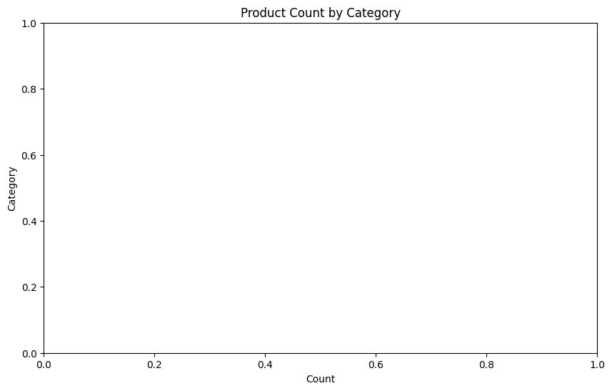

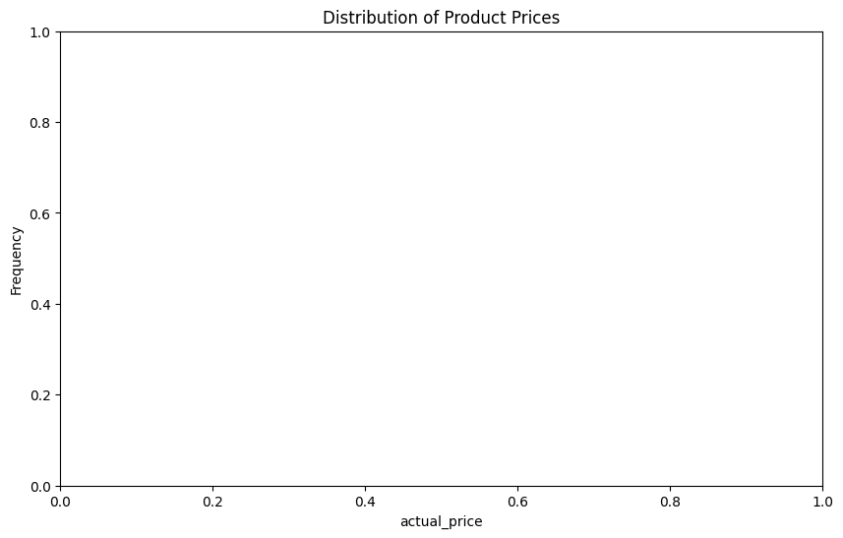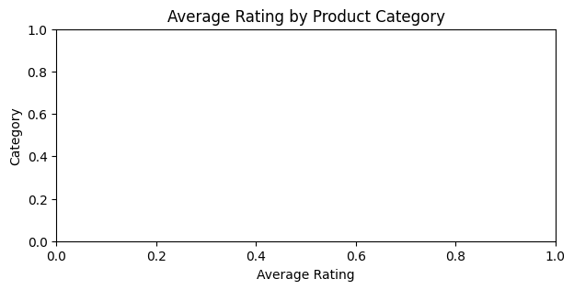

Top 10 Most Expensive Products:

Empty DataFrame

Columns: [product_name, actual_price]

Index: []

